SIMATS ENGINEERING
ASSESSMENT TOOL 1
COURSE NAME: Artificial Intelligence COURSE CODE: CSA17

COURSE OUTCOME COVERED
CO1: Apply AI basics such as intelligent agents and uninformed search methods to solve problems effectively. (BL3)
Assessment Tool Weightage: 50%

QUESTIONS: 5 Duration : 1 Hour
Total Marks:50
Annexure A
Analytical Problem Solving

Code of Conduct:
I Denvar Joe H, 192511438 (Name / Reg No) certify that this submission is my original work and that I have adhered to the guidelines specified for this assessment.
I understand that any violation of academic integrity rules will result in disciplinary action.
Signature of the student:

Annexure A
Analytical Problem Solving
1. Solve the Water Jug problem: you are given 2 jugs, a 4-gallon one and 3-gallon one. Neither has any measuring maker on it. There is a pump that can be used to fill the jugs with water. How can you get exactly 2 gallons of water into 4-gallon jug?
Explicit assumptions: A jug can be filled from the pump, water can be poured out of a jug onto the ground, water can be poured from one jug to another and that there are no other measuring devices available.
2. Find out how Mars Rover, analyse and explore the samples on Mars by answering the following questions.
i. What are the percept's for this agent?
ii. Characterize the operating environment.
iii. What are the actions the agent can take?
iv. How can one evaluate the performance of the agent?
v. What sort of agent architecture do you think is most suitable for this agent? Why?
3. Explore the search space using search strategies and formulate the problem components for the 8-Queens problem using the following information: Place 8 queens on a chessboard such that none of the queen's attack any of the others. A configuration of 8 queens on the board as shown in the figure below, but this does not represent a solution as the queen in the first column is on the same diagonal as the queen in the last column.
4. A customer wants to travel from the one location to another location using OLA Cab booking mobile application. The customer can select the any of the cab type as mini, micro, sedan, shared, prime and so on based on his comfort to reach the destination. Identify what type of problem-solving agent can be used and write the pseudocode for the above problem.
5. A logistics company operates a delivery network where packages must be transported between warehouses at minimum cost. Each route between warehouses has an associated travel cost (fuel + time). The company wants to determine the least-cost path from the starting warehouse S to the destination warehouse G using the Uniform Cost Search (UCS) algorithm.
The delivery network is represented as a weighted graph:
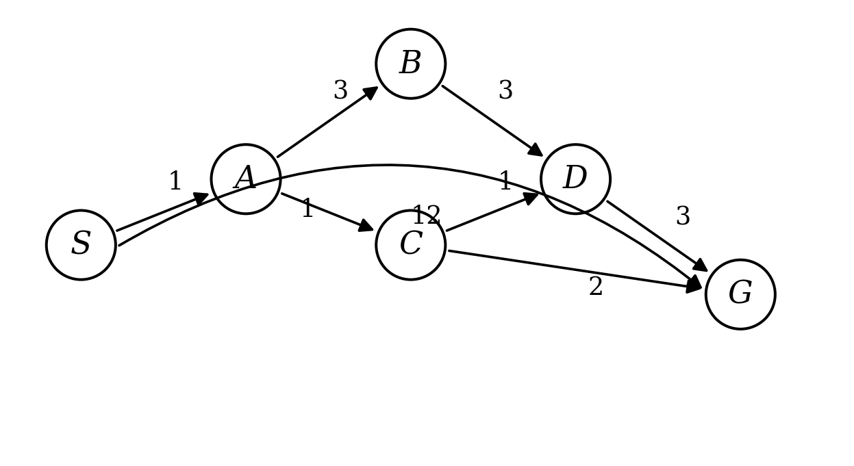
RUBRICS FOR CALCULATION:
Criteria | Weightage | Level 4  (Exemplary) | Level 3  (Proficient) | Level 2  (Developing) | Level 1  (Beginning)
Problem  Understanding | 20% | Clearly interprets problem, identifies all parameters and requirements accurately | Understands problem with minor gaps | Partial understanding; misses key elements | Misinterprets or unable to understand problem
Method  Selection | 20% | Selects most appropriate method/formula with strong justification | Selects correct method with minor errors | Inappropriate or partially correct method | Unable to select method
Solution  Process | 25% | Logical, systematic steps with correct approach throughout | Mostly correct steps with minor mistakes | Disorganized steps; multiple errors | No clear process
Accuracy of  Calculation | 20% | All calculations accurate; correct final answer | Minor calculation errors | Frequent errors; incorrect final answer | No valid calculations
Interpretation  of Results | 15% | Clearly interprets results with units and engineering relevance | Basic interpretation with minor omissions | Limited or unclear interpretation | No interpretation
Problem  Understanding | 20% | Clearly interprets problem, identifies all parameters and requirements accurately | Understands problem with minor gaps | Partial understanding; misses key elements | Misinterprets or unable to understand problem

ANSWERS
Question 1: Water Jug Problem
Answer 1:
Let the 4-gallon jug be X and the 3-gallon jug be Y. A state is written as (X, Y), showing how much water is in each jug at that time. Starting state is (0,0) and we need to reach a state where X = 2.
Step | Action Performed | 4-gal jug (X) | 3-gal jug (Y)
1 | Fill the 4-gallon jug completely | 4 | 0
2 | Pour water from X into Y till Y is full | 1 | 3
3 | Empty the 3-gallon jug Y | 1 | 0
4 | Pour the remaining water from X into Y | 0 | 1
5 | Fill the 4-gallon jug X completely again | 4 | 1
6 | Pour from X into Y till Y is full (Y needs only 2 more) | 2 | 3

At the end of step 6, the 4-gallon jug has exactly 2 gallons of water in it, which is the required answer.
Question 2: Mars Rover Agent
Answer 2:
i) Percepts of the Mars Rover agent:
Camera / image sensor readings of the surrounding terrain, spectrometer and soil analysis data, distance/obstacle sensor values, wheel rotation and slippage data, current location and orientation, battery/solar charge level, temperature and weather condition of the surroundings, and commands sent from the control station on Earth.
ii) Characteristics of the operating environment:
Partially observable – the rover can sense only the area around it and not the whole planet at once.
Stochastic – the outcome of an action (like moving over sand or rock) cannot be predicted with full certainty.
Sequential – the decision taken now will affect the situations that come after it.
Dynamic – weather, sunlight and ground condition on Mars keep changing.
Continuous – the rover's position, speed and sensor values change continuously, not in fixed steps.
Unknown – the surface map of Mars is not completely known beforehand.
iii) Actions the agent can take:
Move forward, backward or turn in a direction, stop and re-plan the route if an obstacle is found, extend the robotic arm to pick a soil/rock sample, drill into a rock, capture images of the surroundings, run the sample through the onboard analyser, send the collected data to Earth, and adjust the solar panel or go into a power-saving mode.
iv) Evaluating the performance of the agent:
The rover's performance can be measured using the distance covered safely without any damage, the number of samples collected and studied correctly, how accurate and complete the data sent to Earth is, how much power/energy was used for the work done, and the time taken to reach the target location.
v) Most suitable agent architecture and reason:
A learning, model-based agent (with goal-based planning) is the most suitable architecture for this rover. Since the Mars surface is only partially observable, the rover needs to keep an internal model/map built from its previous percepts to know where it already has been. It also needs a goal-based part to plan a path towards a rock or sample location, and it should keep learning from its previous movements so that it can avoid similar hazards next time. This is important because Earth control cannot guide the rover in real time due to the communication delay, so the rover has to take most of the decisions on its own.
Question 3: 8-Queens Problem
Answer 3:
The 8-Queens problem can be written as a search problem with the following components:
State: Any arrangement of queens placed on the board, one queen in each column, from column 1 up to the column currently being filled.
Initial state: An empty chessboard with no queen placed on it.
Actions: Place a queen in the next empty column, in any row of that column which is not attacked by a queen already placed.
Goal test: All 8 queens are placed on the board and no queen is attacking any other queen (no two queens share the same row, column or diagonal).
Path cost: Not important in this problem — every move costs the same, since we are only concerned with reaching a valid final arrangement.
Why the given configuration is wrong: In the figure given in the question, the queen placed in the first column and the queen placed in the last column lie on the same diagonal line of the board. Since two queens on the same diagonal can attack each other, this arrangement does not satisfy the goal test and is not a valid solution.
Size of the search space: If we place the queens one column at a time and reject any row that is already attacked, the search only needs to look at about 2057 states before a solution is found. This is a very small number compared to placing all 8 queens on all 64 squares without any restriction (which gives more than 4 billion possible arrangements). Because the search tree grows column by column and many branches can be discarded early using the diagonal/row check, this problem is normally solved using depth-first search with backtracking.
Question 4: OLA Cab Booking Agent
Answer 4:
Type of agent: The cab booking problem is best solved using a Goal-Based Problem-Solving Agent. The customer's goal is fixed (reach the destination), and the app has to search through the available cab options and pick one that satisfies the customer's comfort/cost requirement before booking it. A simple reflex agent cannot be used here because the choice of cab depends on the current traffic, distance, availability and price, which keep changing.
Pseudocode:
START
Read pickup_location, destination_location, comfort_preference
current_location = pickup_location
goal_location = destination_location
cab_list = get_available_cabs(current_location)
// mini, micro, sedan, shared, prime, etc.
for each cab in cab_list:
cab.fare = calculate_fare(current_location, destination_location, cab)
cab.time = calculate_eta(current_location, cab)
chosen_cab = select_best_match(cab_list, comfort_preference)
// checks if fare and comfort match customer's need
if chosen_cab is found:
route = find_shortest_route(current_location, goal_location)
confirm_booking(chosen_cab, route)
display("Cab Booked", chosen_cab, route, chosen_cab.time, chosen_cab.fare)
else:
display("No cabs available, please try again")
STOP
Question 5: Uniform Cost Search on Logistics Network
Answer 5:
From the figure, the edges and their costs are: S–A = 1, S–G = 12, A–B = 3, A–C = 1, B–D = 3, C–D = 1, C–G = 2, D–G = 3.
Applying Uniform Cost Search from S:
Node Expanded | Cost so far | Frontier (nodes waiting to be expanded)
S | 0 | A(1), G(12)
A | 1 | C(2), B(4), G(12)
C | 2 | D(3), G(4) [updated, better than 12], B(4)
D | 3 | G(4) [via D would be 6, so old value 4 is kept], B(4)
G | 4 --> Goal reached | Search stops here

Checking all the possible routes from S to G:
S – G = 12
S – A – C – G = 1 + 1 + 2 = 4
S – A – C – D – G = 1 + 1 + 1 + 3 = 6
S – A – B – D – G = 1 + 3 + 3 + 3 = 10
Final Answer:
The least-cost path from warehouse S to warehouse G is S → A → C → G with a total minimum cost of 4 units.
This means the logistics company should route the package through warehouse A and then warehouse C to reach G, since this path uses the least combined fuel and time cost compared to all other available routes.

